Grazioso Salvare – Rescue Dog Finder (MongoDB + Dash)
Mark Harper
CS-340
August 12, 2025
1) Project Overview & Required Functionality
This project delivers a web dashboard that helps Grazioso Salvare identify dogs suitable for different kinds of search-and-rescue work using the Austin Animal Center Outcomes dataset stored in MongoDB.
The dashboard provides:
- Interactive filters:
  - Water Rescue
  - Mountain/Wilderness Rescue
  - Disaster/Individual Tracking
  - Reset (show all)
- An interactive data table driven by the filters
- A map (leaflet) of animal locations
- A Top Breeds (Top 10) bar chart
- Branding (Grazioso logo) and unique identifier (my name) in the header
Proof of Functionality (Screenshots)
- Starting state (Reset):
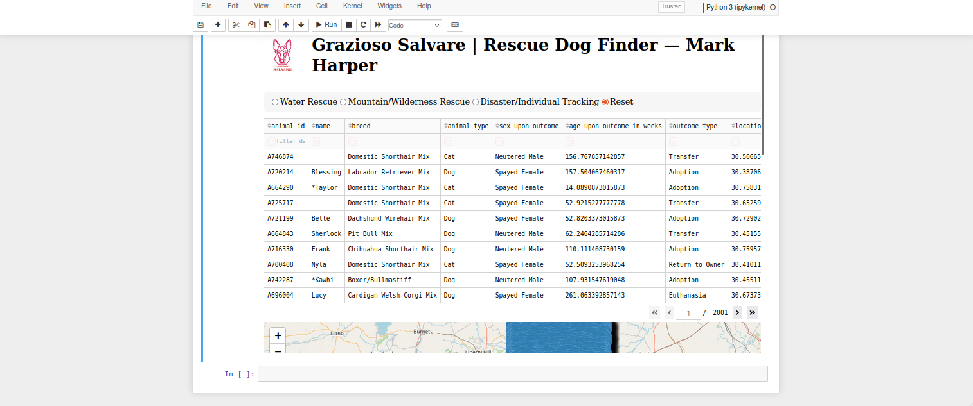
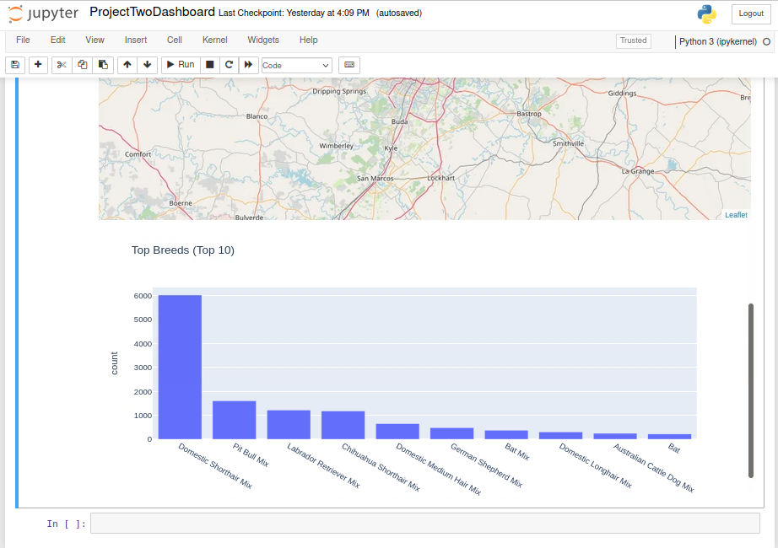
- Water Rescue:
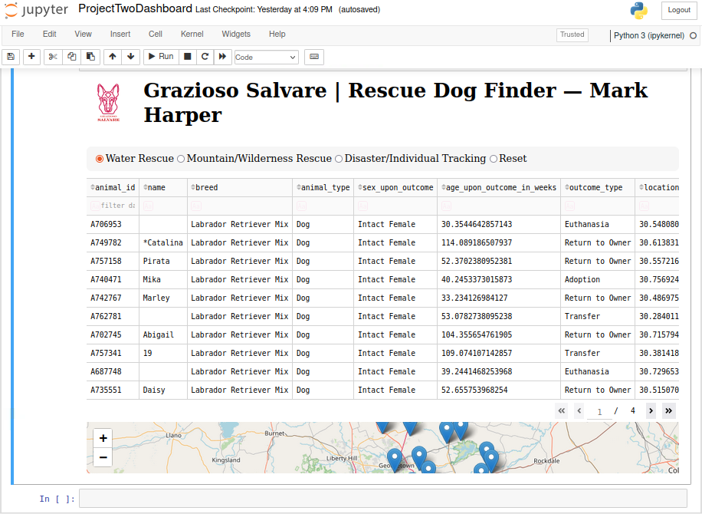
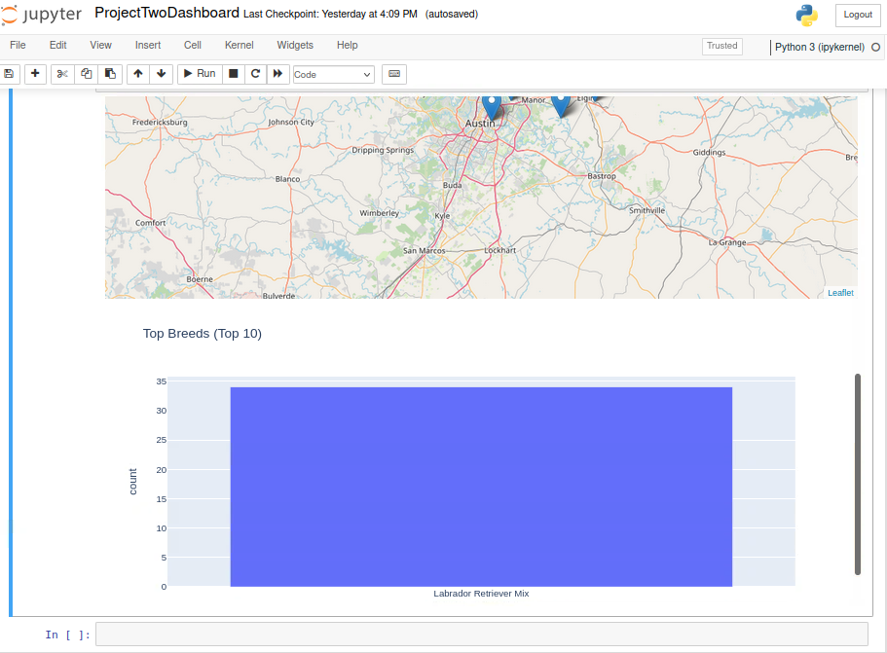
- Mountain/Wilderness Rescue:
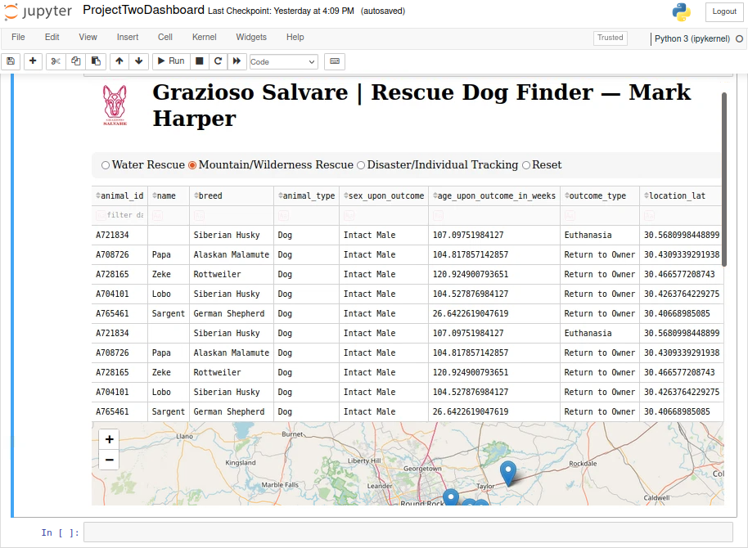
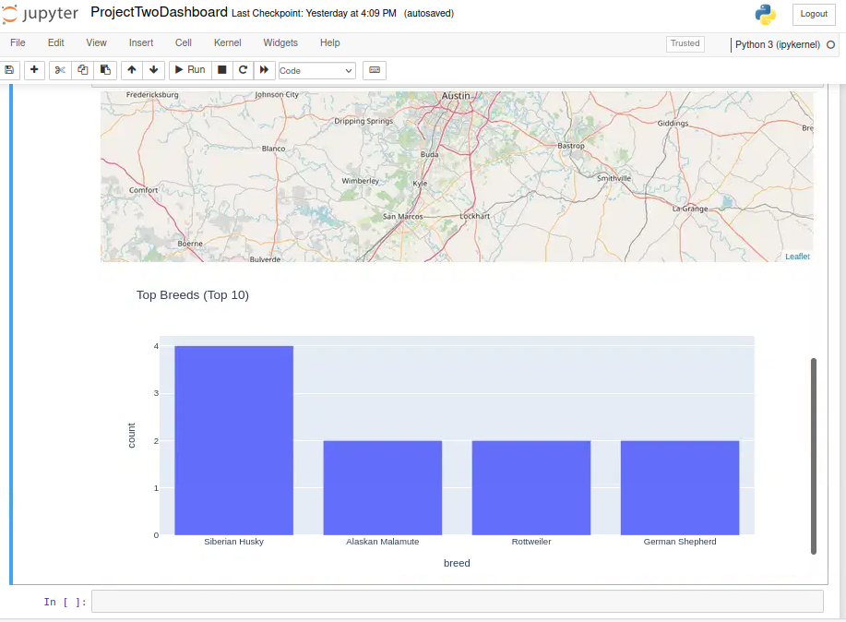
- Disaster/Individual Tracking:
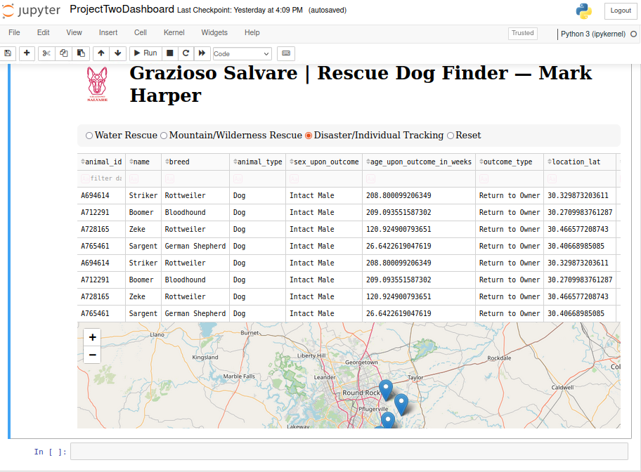
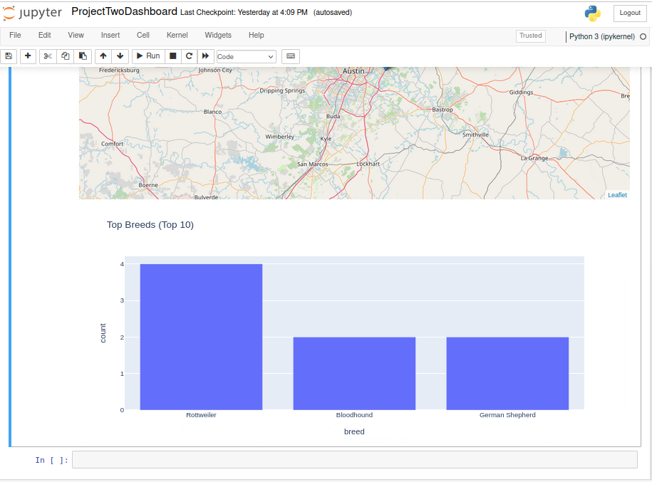

2) Tools, Frameworks, and Why They Were Used
- MongoDB – document database used as the Model. Its flexible schema matches CSV → JSON well, handles semi-structured fields (e.g., breeds, names), and has a first-class PyMongo driver that integrates cleanly with Python/Pandas.
- Python 3 – glue language for the whole stack.
- Dash (by Plotly) – provides the View and Controller:
  - Dash Core Components (dcc) for radio buttons and graphs
  - Dash Table for the interactive table
  - Dash Callbacks for reactive “controller” logic
- dash-leaflet – lightweight, interactive web map to visualize latitude/longitude.
- Plotly Express – quick, attractive charts (Top Breeds bar chart).
- Pandas – tabular manipulation (filtering, type coercion, value counts).
- JupyterDash/Jupyter Notebook – runs the Dash app inside Jupyter for easy development, testing, and screenshots.

3) Architecture (MVC)
- Model: MongoDB collection AAC.animals. Data is retrieved via a small CRUD class AnimalShelter.py (PyMongo). The app queries Mongo with filter criteria derived from rescue rules.
- View: Dash layout—header with logo/name, filter radio items, interactive table, map, and bar chart.
- Controller: Dash callbacks. When a filter is selected, the callback:
  - Builds a Mongo query (sex, breed set, age range).
  - Reads data via AnimalShelter.read().
  - Sanitizes for JSON (e.g., NaN → None).
  - Updates the table, map markers, and bar chart.

4) Rescue Rules (from the Specification)
Filter | Breeds (subset) | Sex | Age (weeks)
Water | Labrador Retriever Mix, Chesapeake Bay Retriever, Newfoundland | Intact Female | 26–156
Mountain/Wilderness | German Shepherd, Alaskan Malamute, Old English Sheepdog, Siberian Husky, Rottweiler | Intact Male | 26–156
Disaster/Individual | Doberman Pinscher, German Shepherd, Golden Retriever, Bloodhound, Rottweiler | Intact Male | 20–300
These rules drive the MongoDB queries.

5) How to Reproduce
A) Prerequisites
- Python 3.9+
- MongoDB instance with the AAC database and animals collection (Austin dataset)
- Jupyter Notebook
Install Python dependencies:
bash
CopyEdit
pip install jupyter-dash dash dash-table dash-leaflet plotly pandas pymongo
B) Load the dataset into MongoDB
(Adjust host/port/path as needed.)
bash
CopyEdit
mongoimport \
--host nv-desktop-services.apporto.com \
--port 30685 \
--username aacuser --password aacuser \
--authenticationDatabase AAC \
--db AAC --collection animals \
--type csv --headerline \
--file "/full/path/to/aac_shelter_outcomes.csv"
Quick check:
bash
CopyEdit
mongosh --host nv-desktop-services.apporto.com --port 30685 \
-u aacuser -p aacuser --authenticationDatabase AAC
use AAC
db.animals.countDocuments()
db.animals.findOne({}, {animal_id:1, breed:1, location_lat:1, location_long:1, _id:0})
C) Project Files
Place these files together:
- ProjectTwoDashboard.ipynb (Dash app)
- AnimalShelter.py (CRUD helper)
- grazioso_logo.png (logo) — or your file name; update the code accordingly
D) Run the Dashboard
- Open ProjectTwoDashboard.ipynb in Jupyter.
- Run all cells.
- The app will render inline; use the radio filters and confirm the table/map/chart update.
Note about _id: AnimalShelter.read() excludes Mongo’s _id to avoid JSON serialization errors:
python
CopyEdit
def read(self, query=None):
q = query or {}
return list(self.collection.find(q, {"_id": False}))

6) Implementation Notes
- Query building: Based on filter key, build a Mongo query with:
  - animal_type: "Dog"
  - breed: {"$in": [preferred breeds]}
  - sex_upon_outcome: {SEX[filter]}
  - age_upon_outcome_in_weeks: {"$gte": lo, "$lte": hi}
- Data sanitation for Dash/JSON:
Dash requires JSON-serializable data; we sanitize Pandas frames:
python
CopyEdit
df_disp = df.astype(object) # numpy → Python scalars
df_disp = df_disp.where(pd.notnull(df_disp), None) # NaN → None
- Map markers:
We drop rows missing coordinates and create a marker with tooltip/popup for each:
python
CopyEdit
for _, r in df.dropna(subset=["location_lat","location_long"]).iterrows():
dl.Marker(position=[float(r["location_lat"]), float(r["location_long"])], ...)
- Top Breeds chart:
python
CopyEdit
top = (df["breed"].dropna().astype(str).value_counts()
.reset_index())
top.columns = ["breed","count"]
fig = px.bar(top.head(10), x="breed", y="count", title="Top Breeds (Top 10)")

7) Challenges & How They Were Solved
- CSV path / mongoimport host placeholders
  - Symptom: “No such file or directory” or couldn’t connect.
  - Fix: Verified exact CSV path with find/Jupyter upload; used correct host/port; quoted paths with spaces.
- Dash 500 error on update (/_dash-update-component 500)
  - Root cause: Mongo’s _id: ObjectId(...) cannot be JSON-encoded.
  - Fix: Excluded _id in AnimalShelter.read() and, in the callback, limited columns to those shown in the table.
- Fitting everything into one screenshot
  - Fix: Browser zoom (80%)
  - Fix: Submit two screenshots each

8) Resources / References
- Dash user guide: https://dash.plotly.com/
- Plotly Express: https://plotly.com/python/plotly-express/
- dash-leaflet: https://dash-leaflet.herokuapp.com/
- PyMongo: https://pymongo.readthedocs.io/
- mongoimport docs: https://www.mongodb.com/docs/database-tools/mongoimport/

9) Reuse & Maintenance
- Configuration (host, port, db/collection) is centralized in AnimalShelter.py.
- Rescue rules (breeds, sex, age windows) are defined in dicts at the top of the notebook—change them as client criteria evolve.
- To deploy as a standalone web app, replace JupyterDash with Dash and run app.run_server(host="0.0.0.0", port=8050).

